TQM Tools
Here follows a brief description of the basic set of Total Quality Management tools. They are:
- Pareto Principle
- Scatter Plots
- Control Charts
- Flow Charts
- Cause and Effect , Fishbone, Ishikawa Diagram
- Histogram or Bar Graph
- Check Lists
- Check Sheets

Pareto Principle
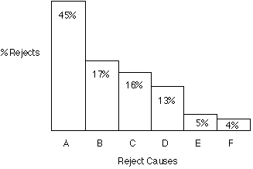
The Pareto principle suggests that most effects come from relatively few causes. In quantitative terms: 80% of the problems come from 20% of the causes (machines, raw materials, operators etc.); 80% of the wealth is owned by 20% of the people etc. Therefore effort aimed at the right 20% can solve 80% of the problems. Double (back to back) Pareto charts can be used to compare 'before and after' situations. General use, to decide where to apply initial effort for maximum effect.
Return to TQM Tools index

Scatter Plots
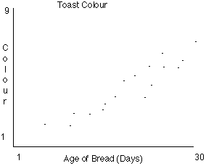
A scatter plot is effectively a line graph with no line - i.e. the point intersections between the two data sets are plotted but no attempt is made to physically draw a line. The Y axis is conventionally used for the characteristic whose behaviour we would like to predict. Use, to define the area of relationship between two variables.
Warning: There may appear to be a relationship on the plot when in reality there is none, or both variables actually relate independently to a third variable.
Return to TQM Tools index

Control Charts
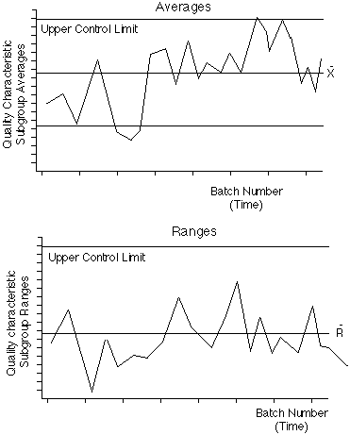
Control charts are a method of Statistical Process Control, SPC. (Control system for production processes). They enable the control of distribution of variation rather than attempting to control each individual variation. Upper and lower control and tolerance limits are calculated for a process and sampled measures are regularly plotted about a central line between the two sets of limits. The plotted line corresponds to the stability/trend of the process. Action can be taken based on trend rather than on individual variation. This prevents over-correction/compensation for random variation, which would lead to many rejects.
Return to TQM Tools index

Flow Charts
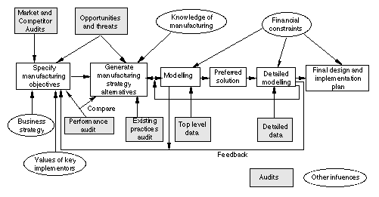
Pictures, symbols or text coupled with lines, arrows on lines show direction of flow. Enables modelling of processes; problems/opportunities and decision points etc. Develops a common understanding of a process by those involved. No particular standardisation of symbology, so communication to a different audience may require considerable time and explanation.
Return to TQM Tools index

Cause and Effect , Fishbone, Ishikawa Diagram
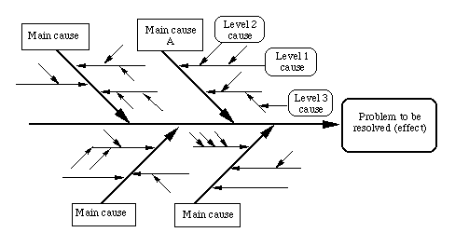
The cause-and-effect diagram is a method for analysing process dispersion. The diagram's purpose is to relate causes and effects. Three basic types: Dispersion analysis, Process classification and cause enumeration. Effect = problem to be resolved, opportunity to be grasped, result to be achieved. Excellent for capturing team brainstorming output and for filling in from the 'wide picture'. Helps organise and relate factors, providing a sequential view. Deals with time direction but not quantity. Can become very complex. Can be difficult to identify or demonstrate interrelationships.
Return to TQM Tools index

Histogram or Bar Graph
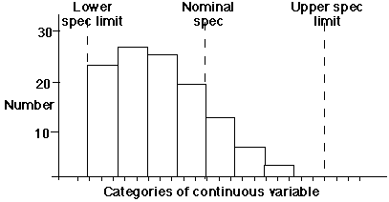
A Histogram is a graphic summary of variation in a set of data. It enables us to see patterns that are difficult to see in a simple table of numbers. Can be analysed to draw conclusions about the data set.
A histogram is a graph in which the continuous variable is clustered into categories and the value of each cluster is plotted to give a series of bars as above. The above example reveals the skewed distribution of a set of product measurements that remain nevertheless within specified limits. Without using some form of graphic this kind of problem can be difficult to analyse, recognise or identify.
Return to TQM Tools index

Check Sheets
A Check Sheet is a data recording form that has been designed to readily interpret results from the form itself. It needs to be designed for the specific data it is to gather. Used for the collection of quantitative or qualitative repetitive data. Adaptable to different data gathering situations. Minimal interpretation of results required. Easy and quick to use. No control for various forms of bias - exclusion, interaction, perception, operational, non-response, estimation.
Return to TQM Tools index

Check Lists
A Checklist contains items that are important or relevant to a specific issue or situation. Checklists are used under operational conditions to ensure that all important steps or actions have been taken. Their primary purpose is for guiding operations, not for collecting data. Generally used to check that all aspects of a situation have been taken into account before action or decision making. Simple, effective.
Return to TQM Tools index

